Chapter 2
Software/IT Project Appraisal

Introduction
- An important consideration in any IT project, whether it is the development of a new system or an investment in new infrastructure, is the business case.
- It has been increasingly recognized that the achievement of business benefits should drive projects.
Business Case Development and Approval
- A business case provides the information required for an organization to decide whether a project should proceed.
- Depending on the organization and often on the size of the investment, the development of a business case is either the first step in a project or a precursor to the commencement of a project.
Business Case Development and Approval
- The initial business case would normally derive from a feasibility study undertaken as part of project initiation/planning.
- Feasibility study is an early study of a problem to assess if a solution is practical, meets requirements within established budgets and schedule requirements.
Feasibility Study
- The development of a new computer system is a major project and is likely to be costly in both resources and money, and will probably cause disruption during development and implementation.
- The project is also likely to have a major effect on the way that the organisation operates.
- Feasibility study is carried out to help provide answers to the following questions:
  - What is required of the system?
  - How can the requirements be satisfied?
  - Is it technically feasible?
  - Is it worth doing?
  - Will the organisation have to change its ways of doing business. Feasibility study will normally include the following six elements:
  - Project Scope.
  - Current Analysis.
  - Requirements.
  - The approach.
  - Evaluation.
  - Formal Review.
Project Scope
- The project scope defines the business problem and/or opportunity to be addressed.
- It should be clear, concise and to the point.
Current Analysis
- This defines and establishes an understanding of a system, a software product.
- Based on this analysis, it may be determined that the current system or software product is working correctly, some minor modifications are needed, or a complete upgrade or replacement is required.
- At this point in the process, the strengths and weaknesses of the current system or software product are identified.
Requirements Definition
- Requirements are defined based upon stakeholder needs and constraints.
- Defining requirements for software differs from defining requirements for systems.
- Examples of needs and constraints used to define requirements:
  - Business, contractual and regulatory processes.
  - End-user functional needs.
  - Technical and physical attributes defining operational and engineering parameters.
The Approach
- This is the recommended system and/or software solution to satisfy the requirements.
- This step clearly identifies the alternatives that were considered and the rationale as to why the preferred solution was selected.
- This is the process wherein the use of existing structures and commercial alternatives are considered (e.g. build versus buy decisions).
Evaluation
- This is based upon the previously completed elements with the feasibility study.
- The final report addresses the cost-effectiveness of the approach selected.
- Elements of the final report include:
  - The estimated total cost of the project if the preferred solution is selected along with the alternatives to provide a cost comparison including:
  - Estimate of employee hours required to complete, material and facility costs, vendors and third party contractors costs, project schedule start and end dates, a cost and evaluation summary encompassing cost-benefit analysis.
Formal Review
A formal review of the feasibility study report is conducted with all stakeholders.
This review will both validate the completeness and accuracy of the feasibility study and render a decision to either approve or reject the project or ask for corrections before making a final decision.
Formal Review
If the feasibility study is approved, all key stakeholders sign the document.
Rationale for rejection of the feasibility study should be explained and attached to the document as part of a lessons learned lists for use in future project studies.
Feasibility study
- Before carrying out a feasibility study, the people involved must know what is expected of them.
- This is set out in a formal document called the Terms of Reference (ToR). ToR document will contain the following tasks:
  - To define what is required of the system?
  - To investigate the existing system, estimating its costs and any problems or short comings.
  - To explore alternative ways of satisfying the system requirement.
Terms of Reference
- To select the most suitable way of satisfying those requirements.
- To prepare a detailed estimate of the cost of developing and operating the system.
- To assess and assign a value to the savings and benefits of running the new system.
- To compare the costs and benefits of developing the systems.
- To recommend whether or not the project should be carried out.
- To prepare a detailed time schedule for implementing the system.
- To specify performance criteria for the system.
- To recommend suitable candidates for the study group assigned to help in the development of the system.
Stages of the feasibility Study
- Formation of the steering committee.
- Setting of the terms of reference.
- Formation of the study group.
- Planning the study.
- Problem definition and information gathering.
- Project identification.
- Cost benefit analysis.
- Producing a feasibility study report.
Formation of the study Group
The steering committee may appoint a system analysts who will then approach people who possess the requisite abilities and experience.
Planning the study
- A program of work is drawn by the project team, with clearly defined timescales and lines of responsibilities.
- A level of flexibility should be built to allow the feasibility study to cover a wide range of activities.

Information Gathering
This stage produce a formal list of the systems requirements, constraints and problems.
- This will require gathering a great deal of information.
- The list of problems and requirements is likely to cover the following areas:
- The data input to the system.
- The output including the contents, level of details and timing.

- The predicted future volumes of transactions and data to be processed.
- Technical feasibility.
- The organizational structure of the user department and their support staff.
- The operational costs of the current system.
- The current hardware and software available together with the list of the current applications using the hardware and software.

Project identification
This will enable the feasibility study group to suggest various options for the project
Eliminate unsuitable options and evaluate the others.
When selecting how to develop the system, select a number of criteria that the system must satisfy e.g. the speed and volume of processing, compatibility with other systems and the need for security.
Cost-Benefit analysis
- For a project to be carried out, the investment criteria set by the organisation must be satisfied. E.g. a criteria might specify that each project must have an internal rate of return of more than 15%.
- Each of project proposals still under consideration will be the subject of analysis, comparing costs of developing a system with its likely benefits.
- In practice, the evaluation of both costs and benefits can be difficult.
- The different elements of costs may be hard to define and the benefits speculative and hard to quantify.
Main features to be examined in Assessing Project feasibility
To be feasible, a project should be justified on the following grounds:
- Economic feasibility study.
- Technological feasibility study.
- Operational feasibility study.
- Social feasibility study.
Economic Feasibility
- The costs can be broken down into 3 basic categories:
- One-off costs e.g. hardware purchase costs, software purchase costs.
- On-going costs e.g. operating staff salaries, training, cost of security equipment’s.
- Intangible costs. These are harder to quantify e.g. staff dissatisfaction, dysfunctional behaviour, opportunity costs, lock-in costs, incompatibility between other systems operating within the organisation and the new system.
- Benefits also range from easily quantified to those that are more difficult to quantify.
- It is impossible to give a complete list of the possible benefits to be derived from a computer system.
- Each system is unique in the benefits it offers.
- However, benefits can be put into two categories:
  - Direct benefits/cost savings.
  - Indirect (intangible) benefits.
Examples of direct benefits
- Savings resulting from the old system no longer operating e.g. staff salaries and consumables.
- Increased capacity e.g. better management of capital by reducing stock levels and collected debts.
Examples of indirect benefits
- Better and informed decision making.
- Improved customer service.
- Freedom from routine decisions and activities.
- Gaining competitive advantage.
Technological Feasibility
The organisation must have the technological ability to cope with the requirements of the system within the allocated budget.
The hardware and software must be capable of dealing with volumes of transactions and required response time, without significant degradation of the existing systems, or there must be enough money available to upgrade the current facilities.
Operational feasibility
The system must fit with the way that the organisation runs its business and plans to run its business in the future.
It must be capable of providing each user with the required information in a timely manner.
Social feasibility
The system must be compatible with the social organisation/company and the company must be sufficiently sophisticated to be able to deal with the complexity of the system being suggested.
This can be split into 3 basic areas:
- The suggested system should not threaten industrial and personal relations and motivations.
- The system must not conflict with the corporate ethics and way of doing business.
- The skills and the experience within the organisation must be at a high enough level to be able to cope with the complexities of the system.
Justifying Investment in New Technology
Much of the difficulty companies have in new technology comes from the techniques traditionally used to make budgeting decisions.
Traditional capital budgeting techniques are:
- Payback Period
- Return On Investment ( ROI )

Payback Period
This calculates the length of time that an investment takes to pay for itself.
- It is easy to calculate and favours low-risk investments, but it ignores cash flows after the investment has paid for itself.
- Although crude, it is extensively used.
Also used in combination with other methods

Payback Period – Example
Project
1
Project
2
Cost
Kshs
100
,
000
150
,
000
Net
Savings
Year
1
50
,
000
20
,
000
Year
2
50
,
000
70
,
000
Year
3
50
,
000
70
,
000
Year
4
50
,
000
70
,
000
Year
5
0
70
,
000
- Project 1 has paid back at the end of the second year, whereas Project 2 does not recover its investment until near the end of the third year.
- By this criterion, Project 1 is the better investment, whereas the total profit from Project 2 is greater.
Return on Investment
ROI calculates the profits on a project as a percentage of the money investment in it.

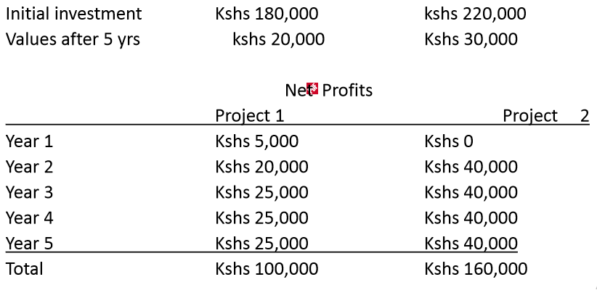
Return on Investment
To calculate the ROI the formula below is used


First, calculate the average profits by finding the total profits and dividing by the number of years.
- Average profit for project 1 = Kshs 20,000 p.a.
- Average profit for project 2 = Kshs 32,000 p.a

Secondly, calculate the average investment. Assuming a straight-line depreciation, this is just the average of the initial investment and the final value.
Third, calculate the ROI: for project 1 = 20% for project 2 = 25.6 %
On this basis, project 2 is a better investment.

ROI
ROI is easy to calculate but ignores the timescale in which the money is earned.
Early income can be reinvested, whereas later income is devalued by the rate of inflation.
Discounted Cash Flow (DCF) Methods
These methods take into consideration the time value of money.
The two principal methods of project appraisal are:
- Net Present Value
- Internal Rate of Return
Net Present Value (NPV)
- This takes the discounted present value of the future cash flows generated by the project, less the initial outlay.
- If the NPV is equal to, or greater than zero, the project should be considered, as it will enhance the value of the firm.
- When using this method to compare projects, the one with the largest NPV should be selected.
Internal Rate of Return (IRR)
This identifies the rate of return that produces an NPV of zero for the project.
If the IRR of the project is greater than the firm’s required rate of return (usually the cost of capital), it should proceed with the project.

